**Name:** Siddhant M Mangale  
**Class:** B.Tech **Div:** A  
**Roll No:** 31

**Experiment No. 5**

Aim: Meta Programming on Julia.

1. Implement Julia Program on Expressions and evaluation  
   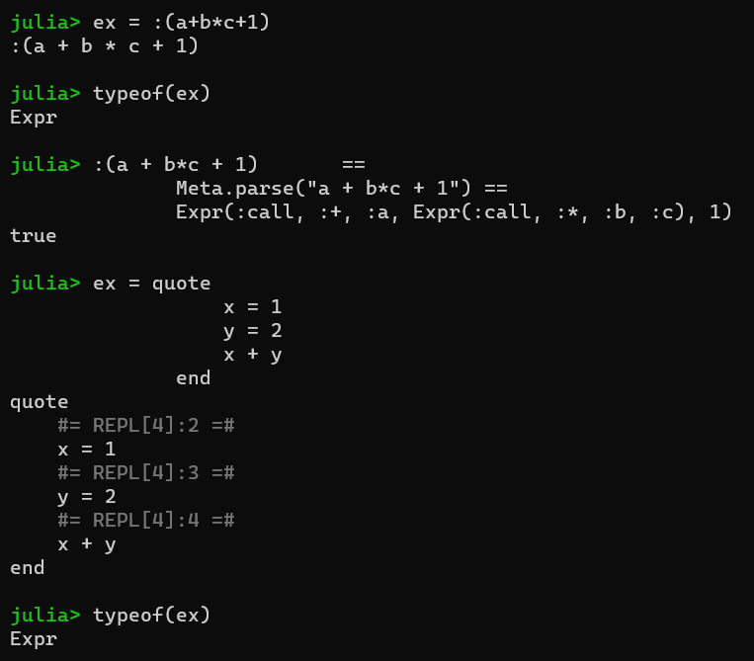
2. Implement Julia Program on Interpolation  
   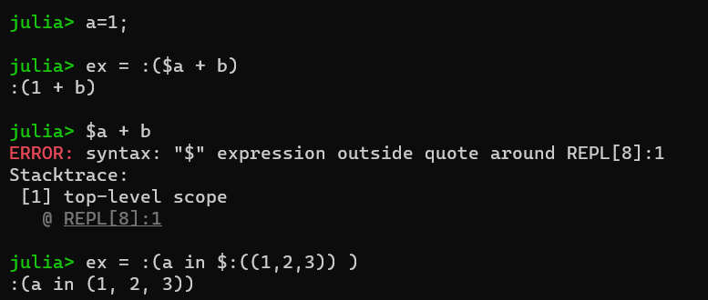
3. Implement Julia Program on Functions on Expressions  
   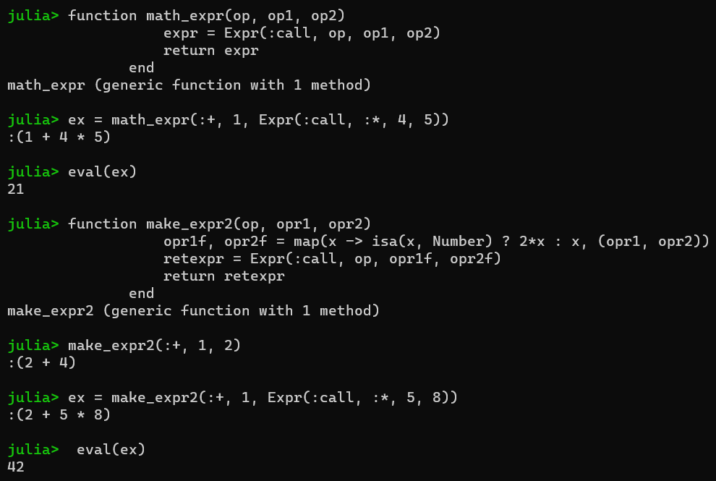
4. Implement Julia Program on Building macro and advanced macro  
   